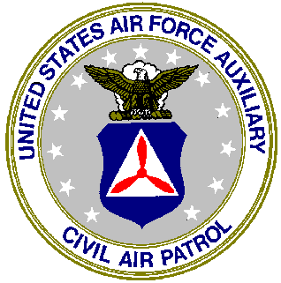
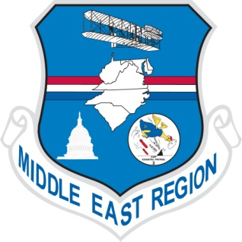
MIDDLE EAST REGION
CIVIL AIR PATROL
UNITED STATES AIR FORCE AUXILIARY
1000 YOUR STREET
ANYTOWN, VA. 22222

June 20, 2013

Mr. John Q. Doe

XYC Company

12345 Main Street, Suite 100

Anytown, VA. 22222

Dear Mr. Doe:

I am writing you on behalf of Wreaths Across America (WAA). The Civil Air Patrol and Wreaths Across America have been in partnership for nearly ten years to provide wreaths to place on the graves of our military veterans at Arlington National Cemetery as well as nearly every other veteran’s cemetery in the nation, and even some overseas. The mission of WAA is to “Remember the Fallen, Honor Those Who Serve and Teach Our Children”. In order to carry out this mission, WAA requests a donation of $15.00 for each sponsored wreath. The wreaths will be placed at Arlington National Cemetery this year on Saturday, December 14th.

We ask our corporate sponsors to support a package of 10 wreaths with a donation of $150. Sponsorships are also available for additional packages of 10 wreaths for each additional $150 donation. If you are so inclined, we welcome your personal or company check payable to Wreaths Across America, which can be mailed to my attention at the address shown above. I will consolidate all of the funds received and forward them directly to Wreaths Across America. If you prefer, I will be happy to come to your office to introduce myself and brief you and/or your staff on the activities of WAA as well as the Civil Air Patrol.

Thank you in advance for your time and your support of Wreaths Across America and I look forward to meeting you.

Best Regards,

Colonel Rick Moseley, CAP

Vice Commander

Middle East Region

703-201-6037

